Interview Task - Data Engineering ETL Pipeline

This document provides comprehensive technical documentation for the Akasa Air ETL (Extract, Transform, Load) Pipeline with integrated analytics dashboard. The solution processes customer and order data from multiple sources (CSV, XML) and provides real-time business intelligence through an interactive web dashboard.

Business Problem & Solution
Problem Statement | Solution Delivered
Process customer data from CSV files | Automated data processing from multiple file formats
Process order data from XML files | Comprehensive data validation and quality checks
Validate and clean data for quality assurance | Scalable database operations with transaction safety
Store processed data in MySQL database | Interactive analytics dashboard for business intelligence
Provide business insights through analytics | Enterprise-grade architecture with proper error handling

System Architecture
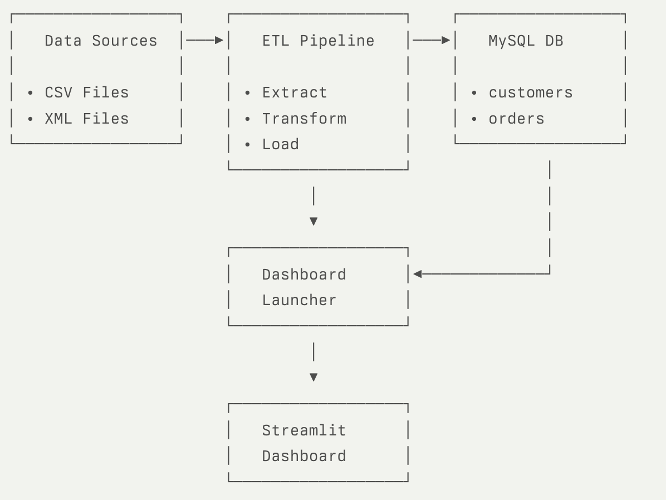
Technical Implementation
1. Configuration Management (config.py)
Purpose: Centralized configuration and database connection management
Key Features:
- Environment variable validation
- Database connection pooling
- Secure credential handling
- Configuration error detection
Implementation Details:
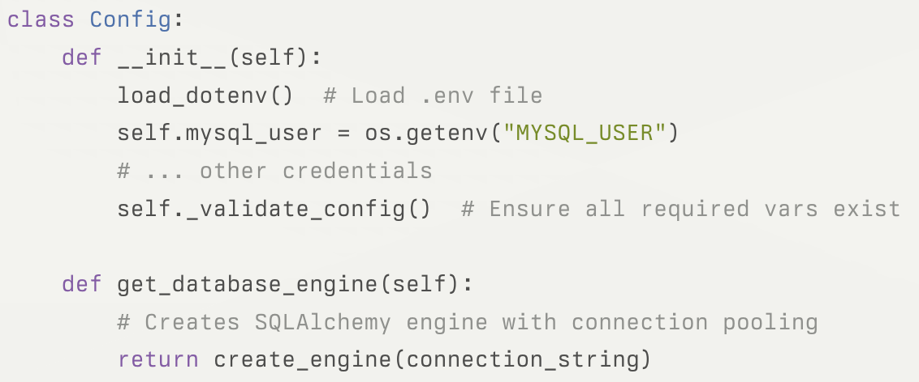
Environment Variable Required
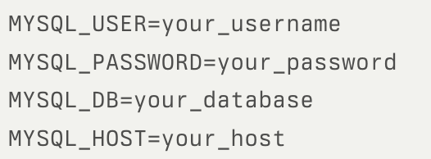

2. Data Processing (data_cleaners.py)
CustomerCleaner Class
Purpose: Process and validate customer data from CSV files

Data Validation Rules:
- Mobile Number: Must match Indian format ^[789]\d{9}$
- Duplicate Detection: Based on customer_id and mobile_number
- Missing Data: Remove rows with null critical fields
- Standardization: Region names converted to Title case
- Column Mapping: Rename columns for database compatibility
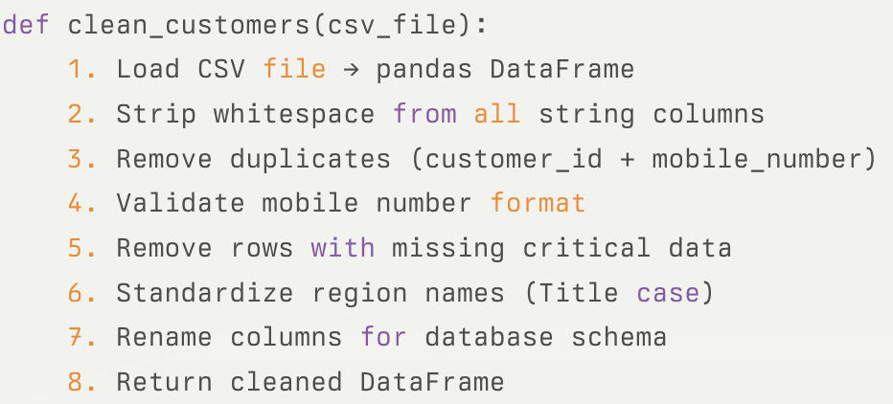
Data Transformations
OrderCleaner Class
Purpose: Process and validate order data from XML files
Data Validation Rules:
- Order ID Format: Must match ^ORD-\d{4}-\d+$ pattern
- Mobile Number: Must match Indian format ^[789]\d{9}$
- Business Rules: Positive amounts and quantities only
- DateTime Parsing: Convert to MySQL-compatible format
- Data Types: Proper type conversion with error handling

Processing Flow:
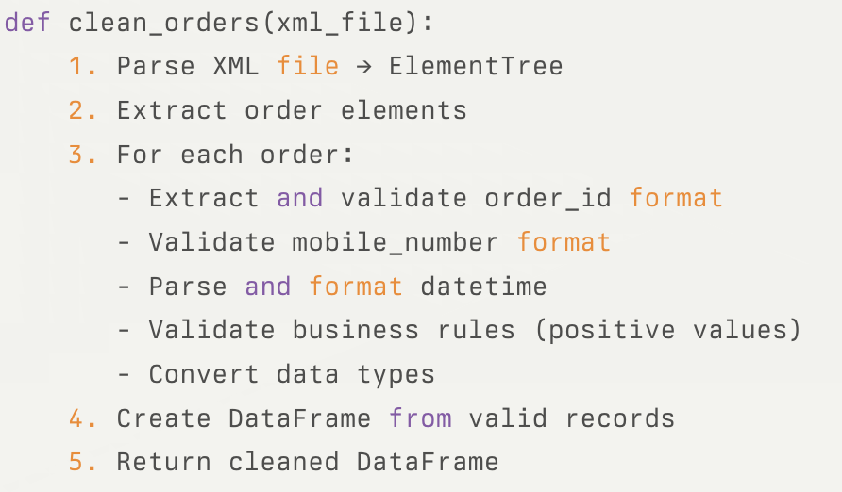
XML Structure Handled:
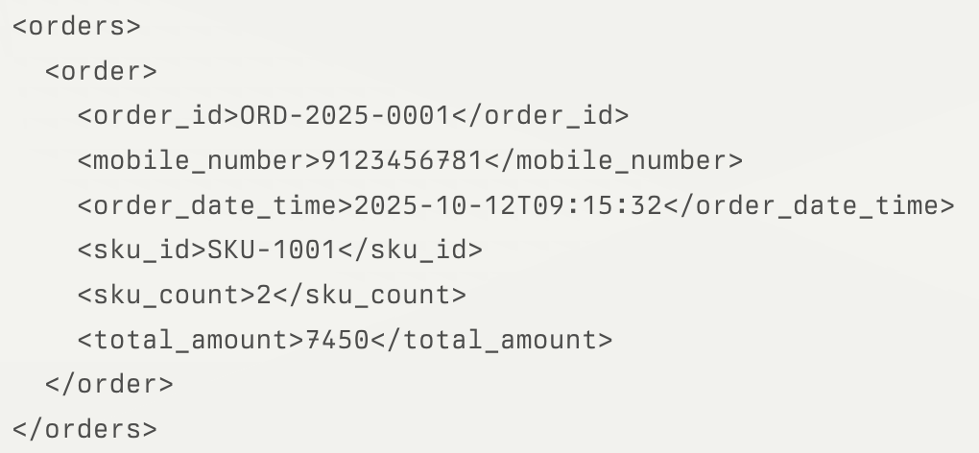

3. Database Operations (database_loader.py)
Purpose: Handle all database interactions with optimization and safety
Key Features:
- Batch Processing: Efficient bulk insertions using method='multi'
- Transaction Safety: Automatic rollback on errors
- Connection Management: Proper resource cleanup
- Error Handling: Comprehensive error logging and propagation

Implementation:
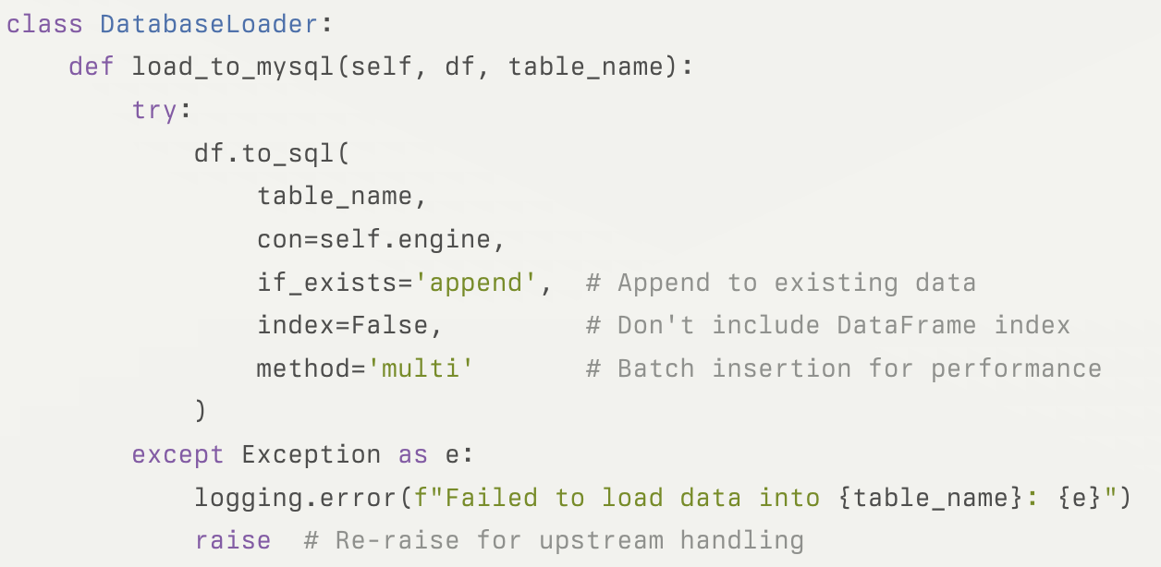
Database Schema:
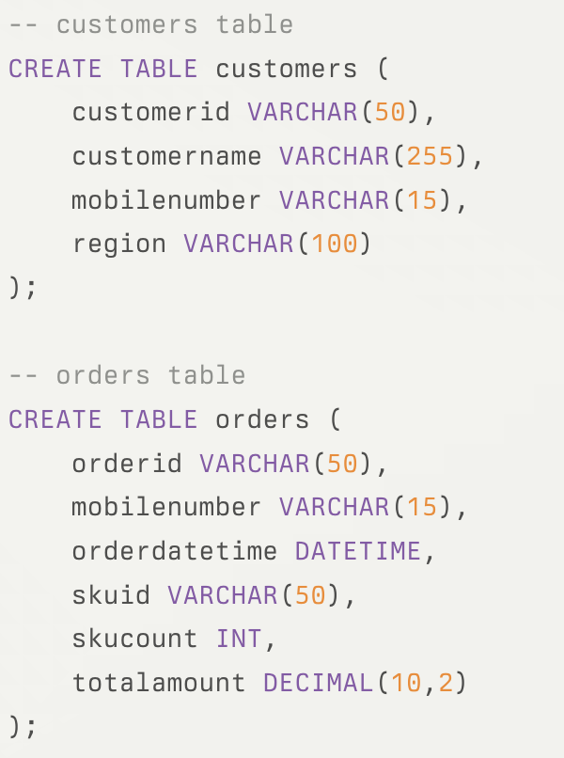
4. Pipeline Orchestration (pipeline.py)
Purpose: Coordinate the entire ETL workflow
Workflow Steps:
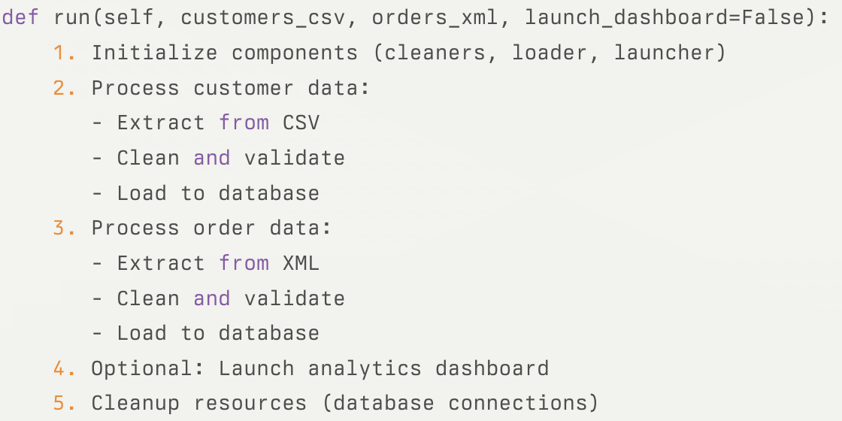
Error Handling Strategy:
- Component-level: Each component handles its own errors
- Pipeline-level: Catches and logs all errors with context
- Resource Cleanup: Ensures database connections are properly closed
- Graceful Degradation: Continues processing when possible

5. Dashboard Application (dashboard_app.py)
Purpose: Provide interactive business intelligence and analytics
Dashboard Architecture
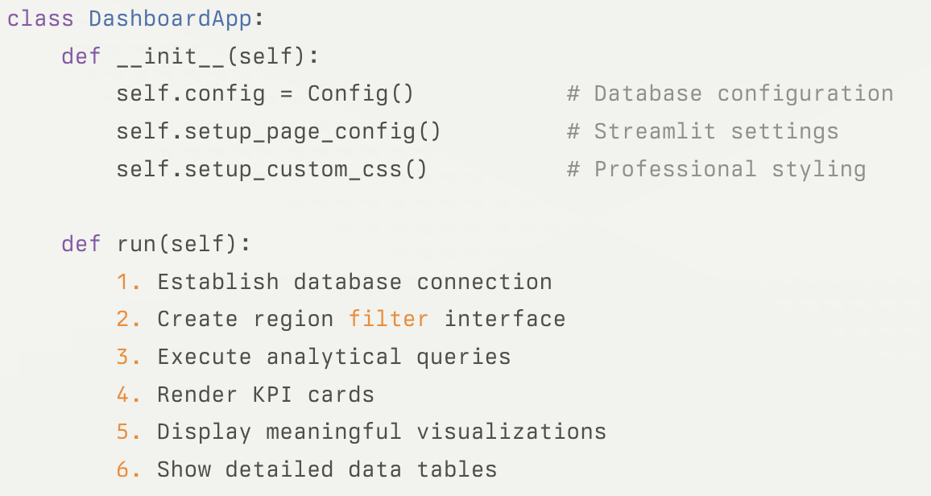
Analytics Queries
- Repeat Customers Analysis
- Monthly Business Trends
- Regional Performance
- Order Value Distribution
See file for full SQL query blocks.
Visualization Strategy
- Monthly Trends: Line chart showing orders and revenue over time (only if multiple months)
- Regional Distribution: Pie chart showing revenue share by region (only if multiple regions)
- Enhanced Data Tables: Growth rates, percentages, averages, formatted display
- Interactive Features: Regional filtering, tabbed views, responsive design

6. Dashboard Management (dashboard_launcher.py)
Purpose: Handle Streamlit dashboard lifecycle and deployment
- Dependency Management
- Process Management
- Browser Integration
- Port Management

7. Command Line Interface (main.py)
Usage Examples: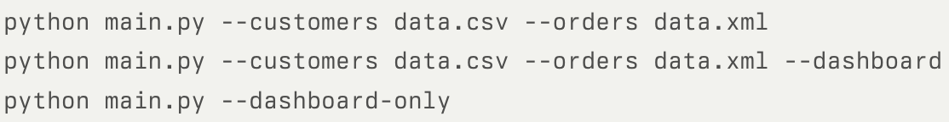
Argument Processing:
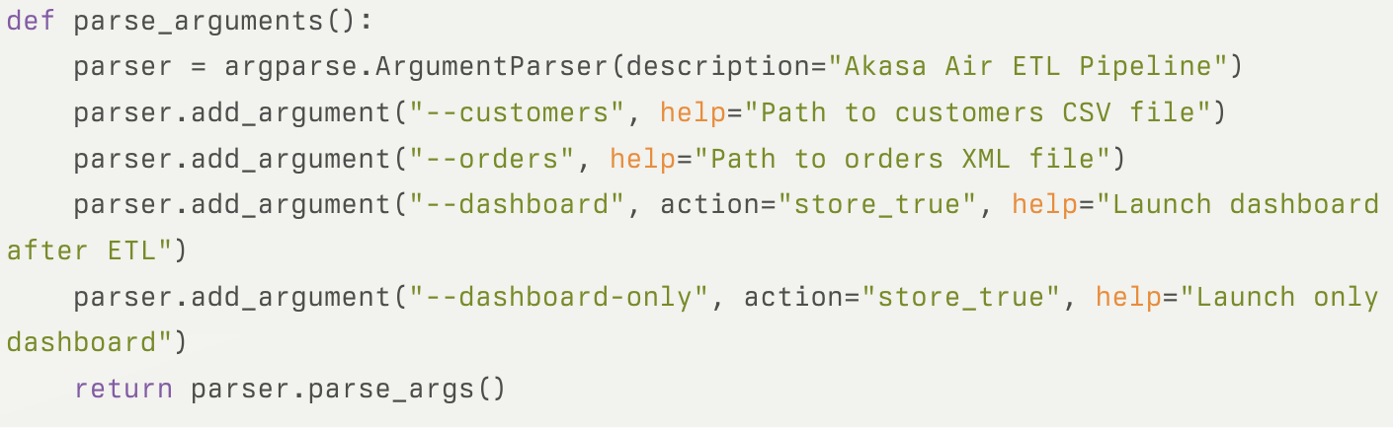

Data Flow & Processing
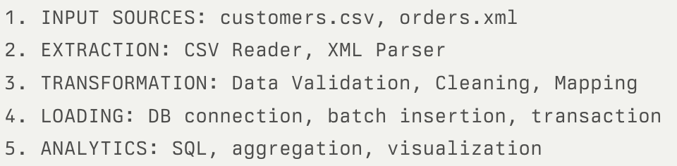
Error Handling Flow:
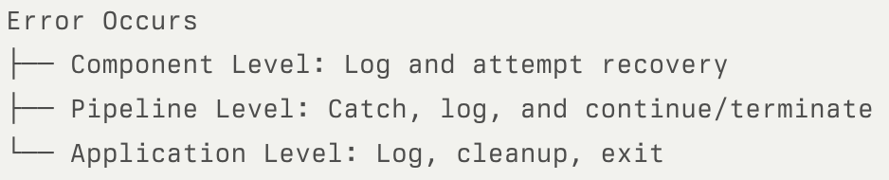
Security & Best Practices
- Credential Management: Environment variables, no hardcoded secrets
- SQL Injection Prevention: Parameterized queries, SQLAlchemy ORM
- Input Validation: Format, business rules, type checking
- Error Information: Sanitized error messages, structured logs

Code Quality Standards:
- Docstrings, type hints, comments
- Modular, SRP, loose coupling

Deployment Guide
Environment Setup:
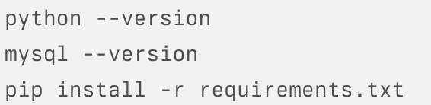
Database Setup:
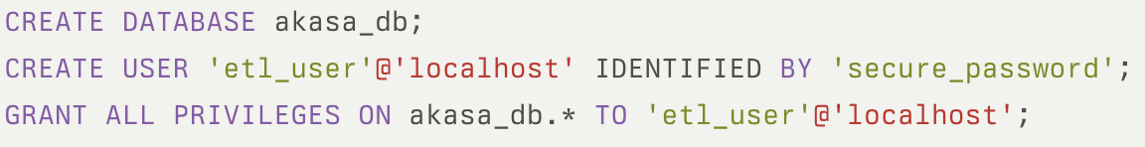
Environment Configuration:
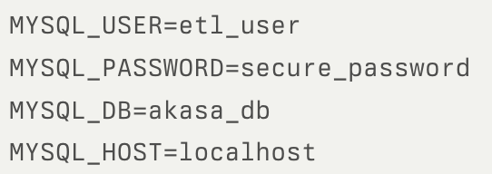
Development & Production Deployment:
